IDEATION PHASE
EMPATHIZE &
Date
Team ID | SWTID-2026-3317 _________________
Project Name | AI FAQ Assistant
Maximum Marks | 4 Marks

Empathy Map Canvas
An empathy map helps the team understand the user's behaviours, thoughts, feelings, needs and challenges. For the AI FAQ Assistant, the map focuses on a student or user who needs quick and reliable answers to frequently asked questions.
Reference: Mural – Empathy Map Canvas

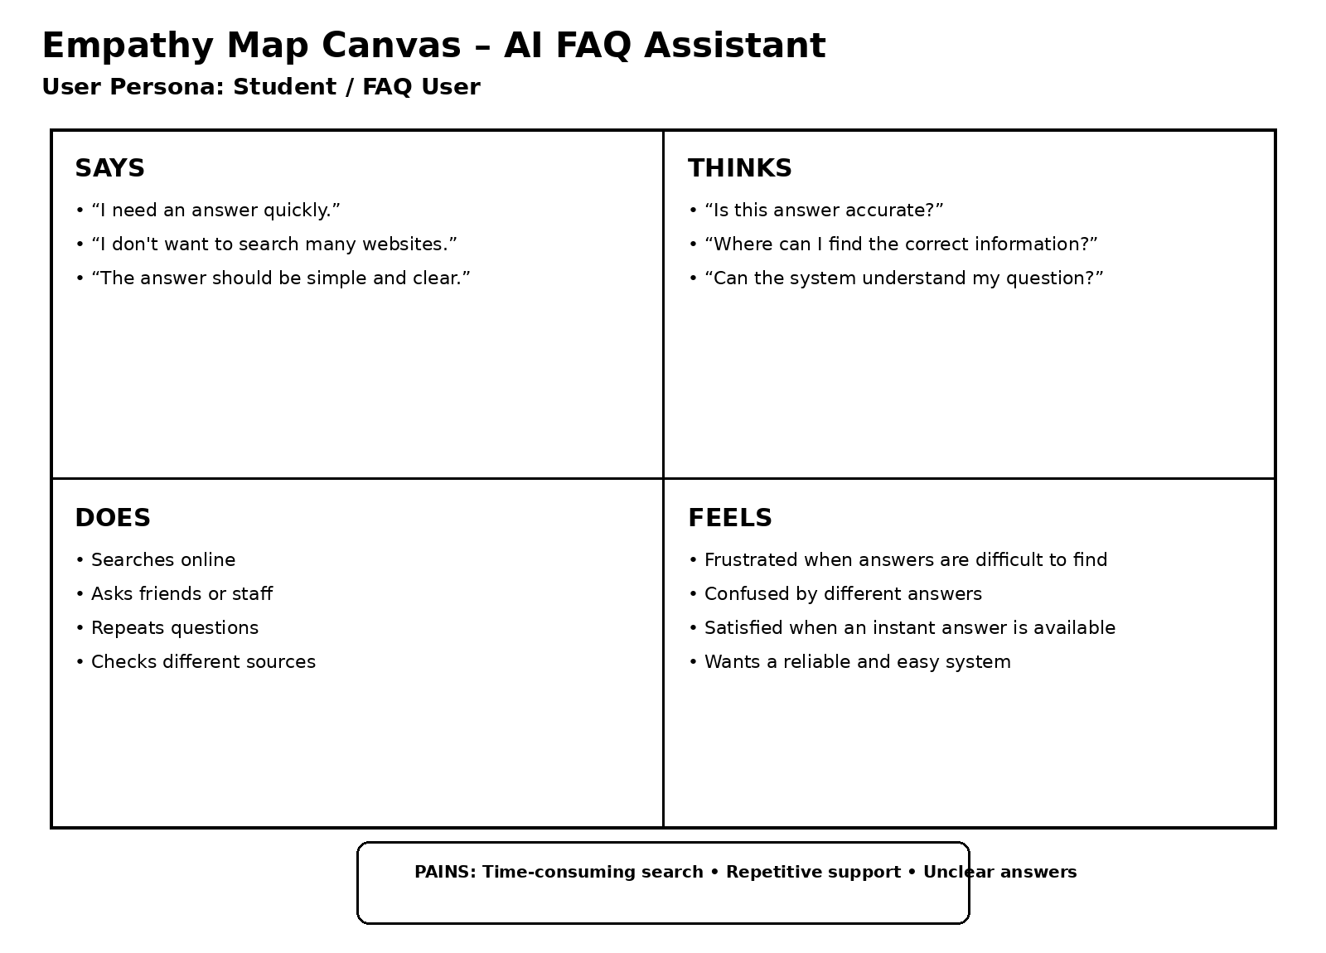

Empathy Map – Detailed Content
Section | User Perspective
SAYS | “I need an answer quickly.”  “I don't want to search many websites.”  “The answer should be simple and clear.”
THINKS | “Is this answer accurate?”  “Where can I find the correct information?”  “Can the system understand my question?”
DOES | Searches online  Asks friends or staff  Repeats questions  Checks different sources
FEELS | Frustrated when answers are difficult to find  Confused by different answers  Satisfied when an instant answer is available  Wants a reliable and easy system
PAINS | Time-consuming searches  Repetitive questions  Unclear or inconsistent answers  Difficulty finding information in one place
GAINS / NEEDS | Quick answers  Accurate information  Easy-to-use interface  Centralized FAQ information  AI-based natural-language support

Key Insight: Users need a centralized AI FAQ Assistant that can understand natural-language questions and provide quick, relevant and easy-to-understand answers.

